Name: Astha Arpit Bhatt

Enrollment: 196140316006

**Practical – 1**

Develop an applet that draws a circle. The dimension of the applet should be 500 x 300 pixels. The circle should be centered in the applet and have a radius of 100 pixels. Display your name centered in a circle. (Using drawOval() method).

**CODE:**

import java.applet.Applet;

import java.awt.*;

public class pra1 extends Applet

{

public void paint(Graphics g)

{

g.drawOval(200,100,100,100);

g.drawString("Astha",238,150);

}

}

/*

<applet code="pra1.class" width="500" height="300">

</applet>

*/

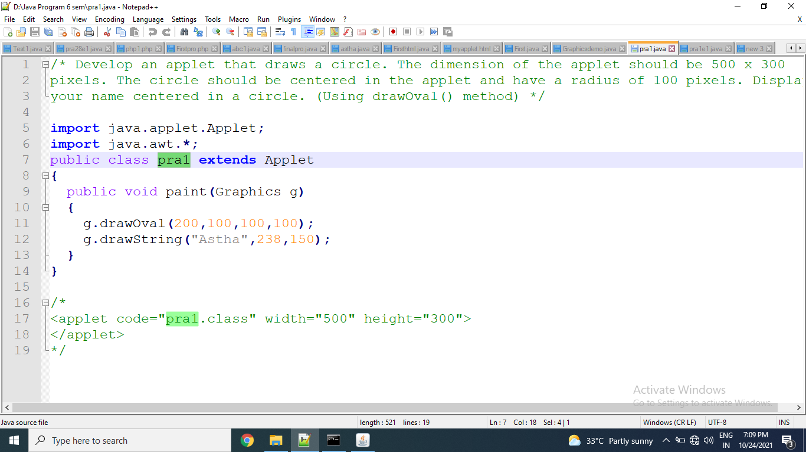

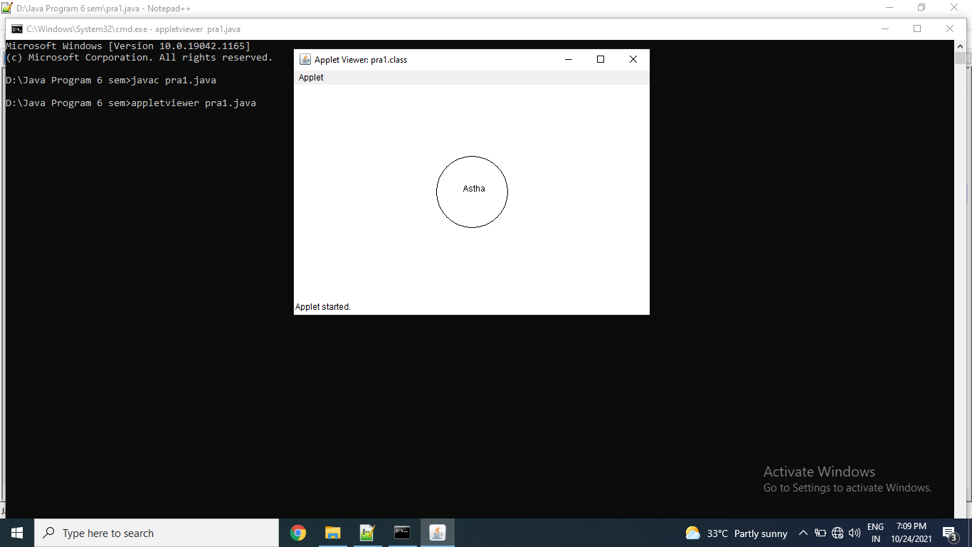

**Exercise:**

1. Draw a circle and square near circle in center of the applet.

import java.applet.Applet;

import java.awt.*;

public class pra1e1 extends Applet

{

public void paint(Graphics g)

{

g.drawOval(100,100,150,100);

g.drawRect(300,100,150,100);

}

}

/*

<applet code="pra1e1.class" width="500" height="300">

</applet>

*/

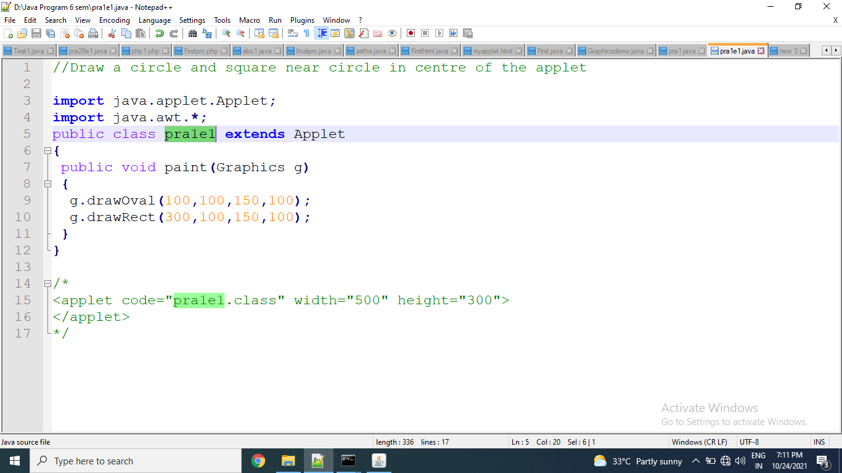

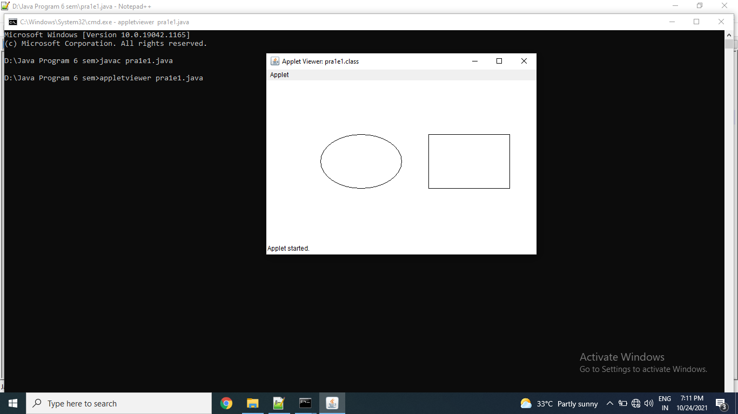

1. Draw a rectangle inside an oval in top left corner of the applet.

import java.applet.Applet;

import java.awt.*;

public class pra1e2 extends Applet

{

public void paint(Graphics g)

{

g.drawOval(0,0,170,120);

g.drawRect(33,25,100,70);

}

}

/*

<applet code="pra1e2.class" width="300" height="300">

</applet>

*/

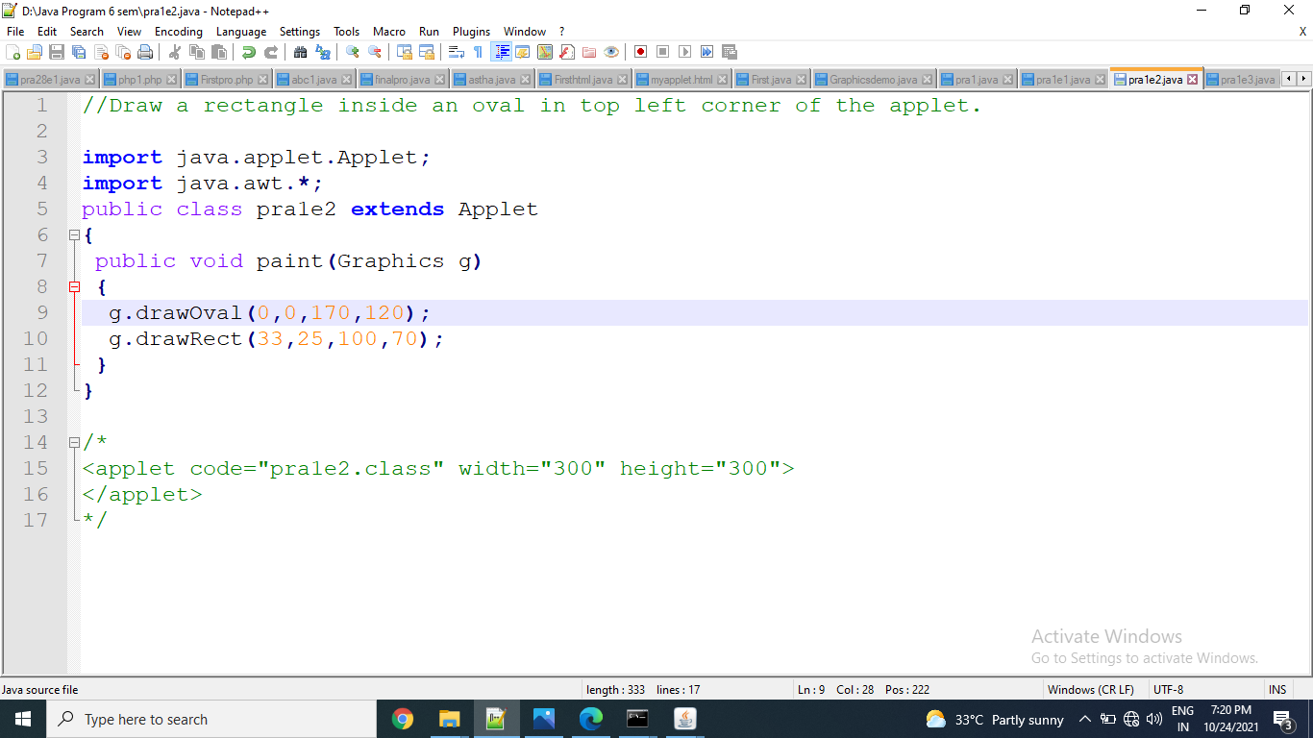

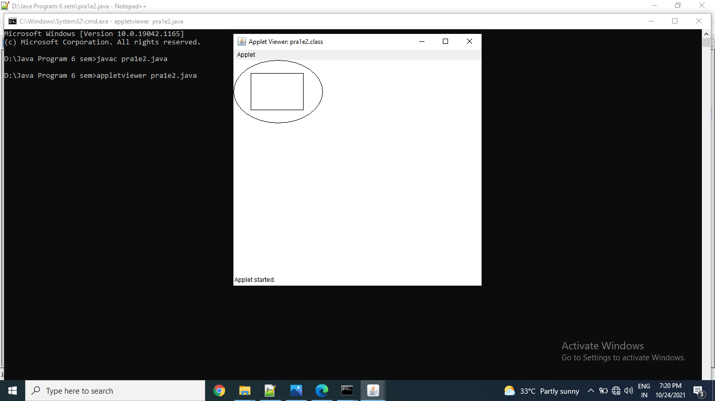

1. Draw the following ouput using drawLine function.

import java.applet.Applet;

import java.awt.*;

public class pra1e3 extends Applet

{

public void paint(Graphics g)

{

g.drawLine(10,10,100,10);

g.drawLine(10,10,100,90);

g.drawLine(10,90,10,200);

}

}

/*

<applet code="pra1e3.class" width="300" height="300">

</applet>

*/

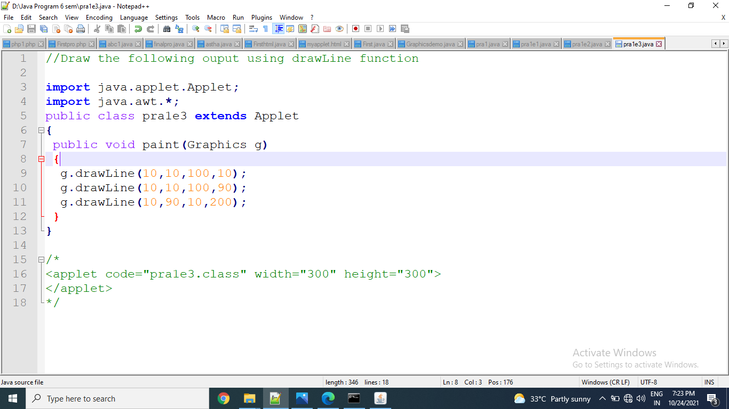

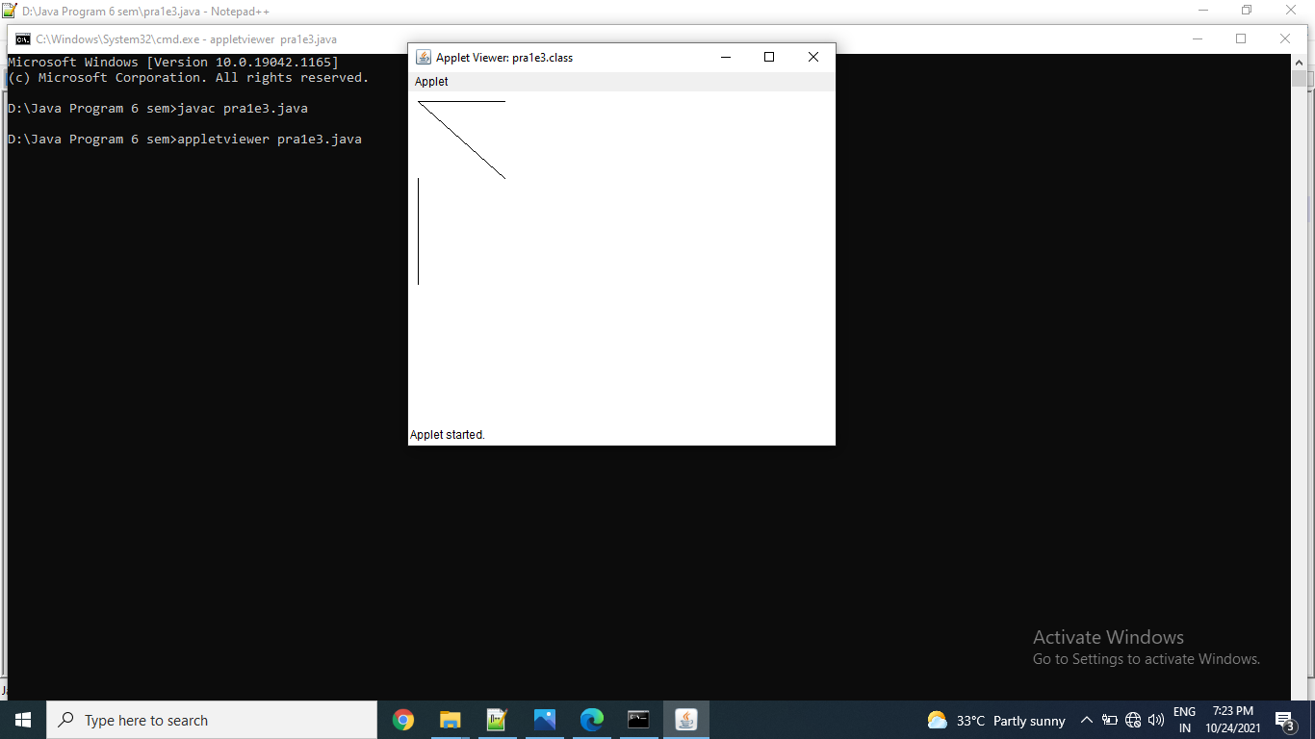

Thanks mam!!!